

Process Vendor Invoice
Process Design Document (PDD)

Raya Information Technology
Authored by: Yasser Salah Mohamed
Raya Information Technology
Authored by: Yasser Salah Mohamed



Process Design Document History

Date | Version | Role | Name | Organization | Function | Comment
31.08.2025 | 1.0 | Author | Mohamed Mesbah | ACME Systems Inc. | SME | Creation v 1.0
01.09.2025 | 1.1 | Reviewer | Yasser Salah | Raya | BA | Approved v 1.0

Table of Contents
1. Objective 4
1.1 Business Objectives and Benefits 4
2. Current Process 4
2.1 Process Overview 4
2.2. Standard of Metrics 5
2.3. Volume of data 5
3. Business Rules 6
4. High Level Process Diagram 6
5. Detailed Process Steps – AS IS 6
6. In Scope for RPA 10
7. Out of Scope 10
8. Non-process requirements 10
8.1 Systems 10
8.2 Reporting 10
8.3 Archiving 10
8.4 Security & data retention 10
9. Exception Handling 11
10. Escalations 12

Objective

The objective of WI3 – Process Vendor Invoice in ACME System 1 is to ensure vendor invoices are received, validated, and recorded accurately in alignment with purchase orders and goods receipts, enabling timely payments and compliance with financial policies.
Automation within this process aims to:
- Reduce repetitive manual data entry.
- Minimize processing errors and mismatches.
- Accelerate invoice turnaround time.
- Improve transparency and compliance tracking.
- Free employees to focus on exception handling and higher-value activities.

Business Objectives and Benefits

Objectives |  | Expected Benefits
Eliminate manual data entry and comparison | Saves employee time and effort by reducing repetitive work.
Reduce human error in reconciliation | Improves accuracy and reliability of financial records.
Increase processing speed and consistency | Allows large volumes of accounts to be processed faster and in a standardized way.
Free employees for exception handling and value-added tasks | Enhances productivity and employee engagement by shifting focus to higher-value activities.
Ensure auditability of processed transactions | Provides consistent logs and evidence for compliance and audit purposes.

Current Process

Process Overview

The WI3 – Process Vendor Invoice in ACME System 1 covers the end-to-end handling of vendor invoices from receipt to validation and posting. The process ensures that invoice details are accurate, compliant, and aligned with purchase orders and goods receipts before being approved for payment. Automation supports the process by handling repetitive data entry, validation checks, and system updates, while employees manage exceptions and approvals.

2.2. Standard of Metrics

General information about the process selected for RPA, prior to automation:

Process name | Process Vendor Invoice
Function | Invoice Processing
Department | Finance / Accounting
Process short description | Handles vendor invoices in ACME System 1 by capturing details, validating against purchase orders and receipts, applying business rules, and posting for payment.
Process schedule | Runs daily on business days. Invoices are picked up from the ACME System 1 WI3 queue at scheduled intervals (e.g., every hour) until the working day ends.
#of items process/month | ~ 2,000 – 2,500 invoices per month (average volume, may vary by vendor activity and business cycle).
Average cycle time | ~ 5–7 minutes per invoice with automation.
Average handling time | ~ 3–5 minutes per invoice for automated cases
Peak period(s) | End of each month, quarter, and fiscal year when vendor invoice submissions and payment processing volumes are highest.
# of FTE supporting this activity | ~ 3 Full-Time Employee (FTEs) in the Accounts Payable team handle invoice processing, exception management, and approvals.
Input Data | Vendor Invoice Details (Primary document containing invoice details.)
Output Data | Validated and posted vendor invoice record in ACME System 1, updated work item status
Return on investment | Automating WI3 – Process Vendor Invoice reduces manual effort and errors, shortens processing time by over 50%, decreases FTE dependency, and delivers cost savings along with faster vendor payments and improved compliance.

2.3. Volume of data

Activity | Time taken per month (hours) | Volume of data to be processed
Logging into ACME System 1 | ~5 hours | N/A (single login per session)
Invoice Retrieval (from WI3 queue) | ~20 hours | ~2,000–2,500 invoices
Data Extraction & Entry | ~80 hours | ~2,000–2,500 invoices
Validation (PO & GR match, tax, duplicates) | ~100 hours | ~2,000–2,500 invoices
Exception Handling (mismatches, missing data) | ~40 hours | ~300–400 invoices
Posting & Status Update in ACME System 1 | ~30 hrs | ~2,000–2,500 invoices
Refers to the number of vendor invoices processed in ACME System 1, averaging 2,000–2,500 invoices per month, with ~300–400 falling into exception handling.

Business Rules

BR# | Requirement | Additional Information
#BR001 | Duplicate invoices must be rejected. | Based on vendor ID + invoice number + amount check.
#BR002 | Tax codes must be valid and correctly applied. | Validated against master data in ACME System 1.
#BR003 | Vendor must exist in master data. | Invoices from unregistered vendors are flagged for review.
#BR005 | All WI1 items must be processed within the same reporting cycle. | Typically daily, with higher volumes during month-end or quarter-end.
#BR006 | User must log in with valid credentials before accessing work items. | Credentials are managed by the organization’s IT/security policies.

High Level Process Diagram
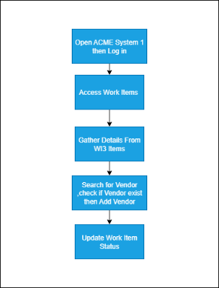

Detailed Process Steps – AS IS
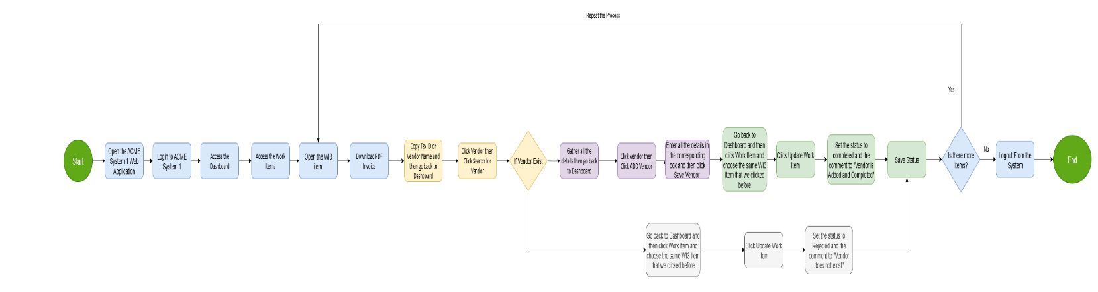

Steps | Description | Screenshots | Exception Handling
1 | Open the ACME System 1 Web Application |  | #SE001
2 | Log in to ACME System 1 using valid credentials. | 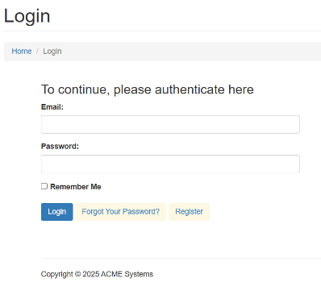 | #SE003
3 | Access the Dashboard, it’s the central location where the user can pick a specific menu item | 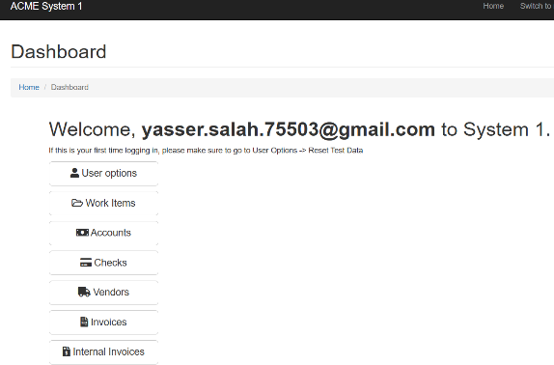
4 | Access the Work Items Listing to consult all the available tasks to perform (Output data: task) | 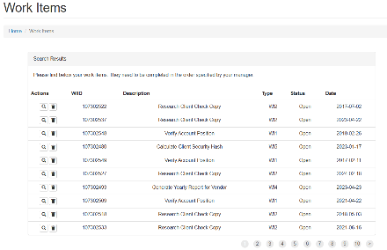 | #BE001
5 | Open WI3 item. | 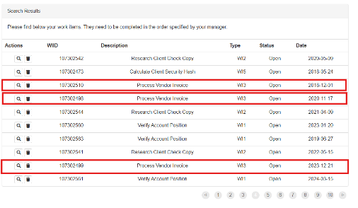
6 | For each activity of the type WI3 perform the following steps
6.1 | Click Download PDF Invoice | 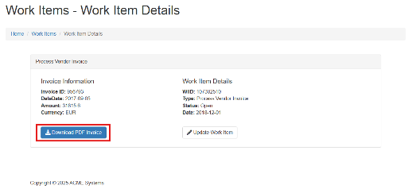
6.2 | Copy Tax ID, or Vendor Name to check if the vendor exist | 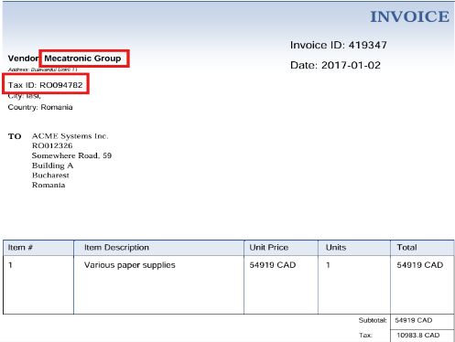 | #SE004
6.3 | Go back to the Dashboard and select Vendors then select search for vendor | 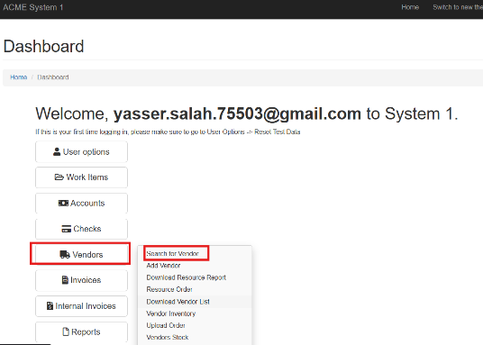
6.4 | Enter the Tax ID, or the Vendor Name we Copied before and then click search | 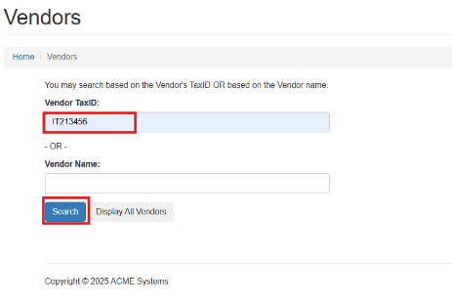 | #BE004
6.5_Yes | If Vendor exist copy this details | 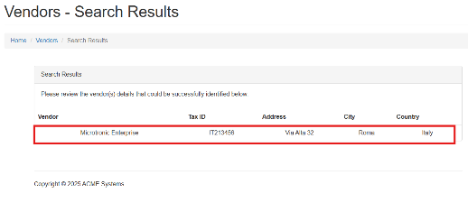 | #BE002
6.6_Yes | Go back to Dashboard ,then select Vendors and then select Add Vendor | 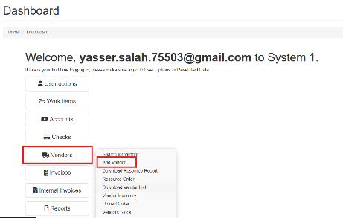
6.7_Yes | Enter the data we copied before and then click Save Vendor | 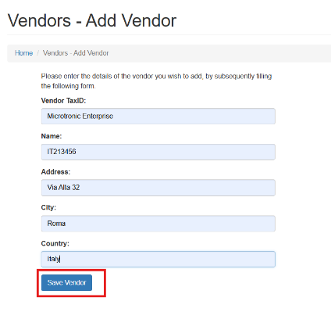
6.8_Yes | Go back to Dahboard then click Work Item then click the same WI3 Item we clicked before then click Update Work Item | 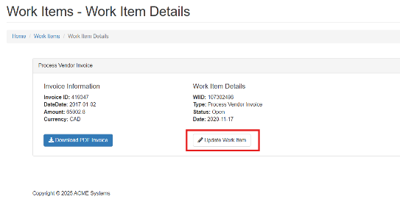
6.9_Yes | Set the status to Completed and the Comment to “Vendor is Added and Completed”. Then click Update Work Item | 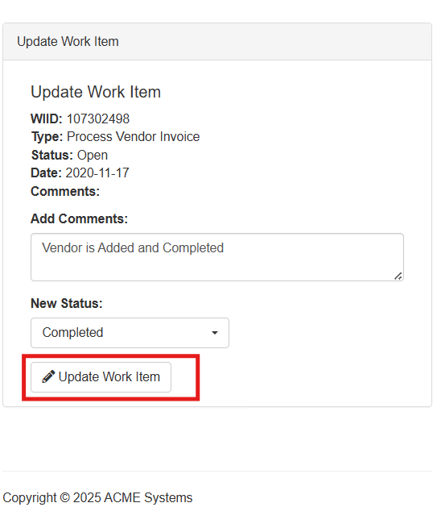
6.5_No | If Vendor does not exist | 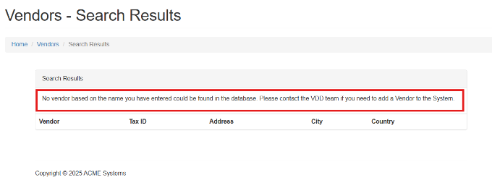 | #BE003
6.6_No | Go back to Dahboard then click Work Item then click the same WI3 Item we clicked before then click Update Work Item | 
6.7_No | Set the status to Rejected and the Comment to “Vendor does not exist”. Then click Update Work Item | 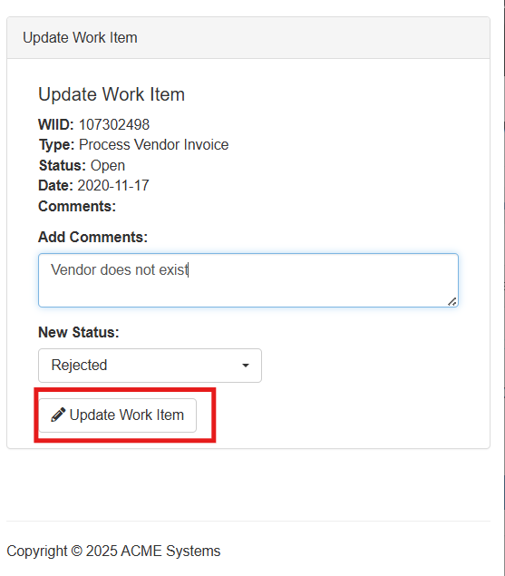
7 | If there more Items Continue with the next WI1 Activity
8 | Logout

In Scope for RPA

The activities and exception in of scope for RPA, in this automation workflow /sequence are listed here:
-  Full Scope of the process for RPA - to be 100% automated

Out of Scope
- There are no activities out of scope for RPA …

Non-process requirements

Systems

System | Usage | Frequency
ACME System 1 | Core system used for invoice retrieval (WI3), validation, posting, and reporting. | Daily (multiple times per day)

Reporting

Report name | Source | Purpose
Invoice Processing Report | ACME System 1 | Provides summary of invoices processed (successful, failed, pending).
Exception Report | ACME System 1 | Lists invoices with mismatches, missing data, or failed validations for manual review.
Compliance & Audit Report | ACME System 1 | Ensures invoices are processed according to financial policies and audit standards.
Vendor Master Data Report | ACME System 1 | Confirms vendor information is up-to-date for accurate invoice processing.

Archiving

All processed invoices and related reports are securely stored in ACME System 1 for future reference, compliance, and audit purposes, according to the company’s data retention policy.

Security & data retention

Security & Data Retention: Access to invoice data is restricted to authorized users only, with role-based controls in ACME System 1. All processed invoices and related records are retained securely for a minimum of 7 years to comply with financial and audit regulations.

Exception Handling

- Business Exception

#Business Exception no. | Business Exception | Description | Expected Action
#BE001 | There is no work items | WI3 Items does not exist | Raise exception for review; request to update the list
#BE002 | Duplicate Invoice | Same vendor + invoice number already processed. | Reject or flag invoice; notify AP team.
#BE003 | Invalid Vendor | Vendor not found in master data. | Route to master data team or reject invoice.
#BE004 | Incorrect Tax Code | Tax details missing or invalid. | Escalate for finance review.
#BE005 | Missing/Unreadable Data | Scanned invoice is unclear or incomplete. | Request resubmission from vendor.

- System/Application Exception

# System Exception no. | Exception | Description | Expected Action
#SE001 | System Unavailability | ACME System 1 is down or under maintenance. | Retry after system recovery; log downtime.
#SE002 | Slow System Performance | Invoice queue takes longer to load or process. | Escalate to IT support; monitor queue backlog.
#SE003 | Login/Authentication Failure | User or bot unable to log in due to invalid credentials or expired password. | Reset credentials; escalate to IT/security team.
#SE004 | Data Extraction Error | Invoice data fields not captured correctly (OCR/formatting issue). | Re-run extraction; escalate if repeated.
#SE005 | Timeout/Error Message | Session times out during validation or posting. | Restart process; log error; escalate if frequent.

Escalations

For immediate contacts for the process automation project, kindly contact the respective contact on the table below:

Email Address | Roles | Responsibilities
sme.ap@acme.com | Subject Matter Expert (SME) | Provides process knowledge, clarifies business rules, and assists in resolving complex invoice exceptions.
senior.dev@acme.com | Senior Developer | Handles automation-related issues, fixes workflow errors, and ensures bot stability and performance.
ba@acme.com | Business Analyst | Analyzes exception trends, validates requirements, and coordinates between business users, SMEs, and developers for resolution.

